**Capstone Project-Grocery Application**

**Screenshots**

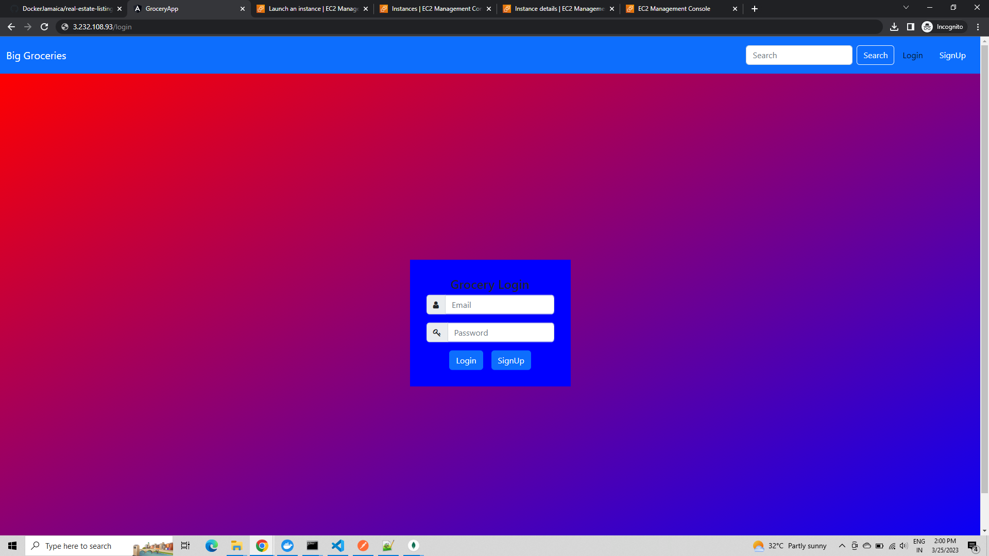

**On entering the username and password of customer**

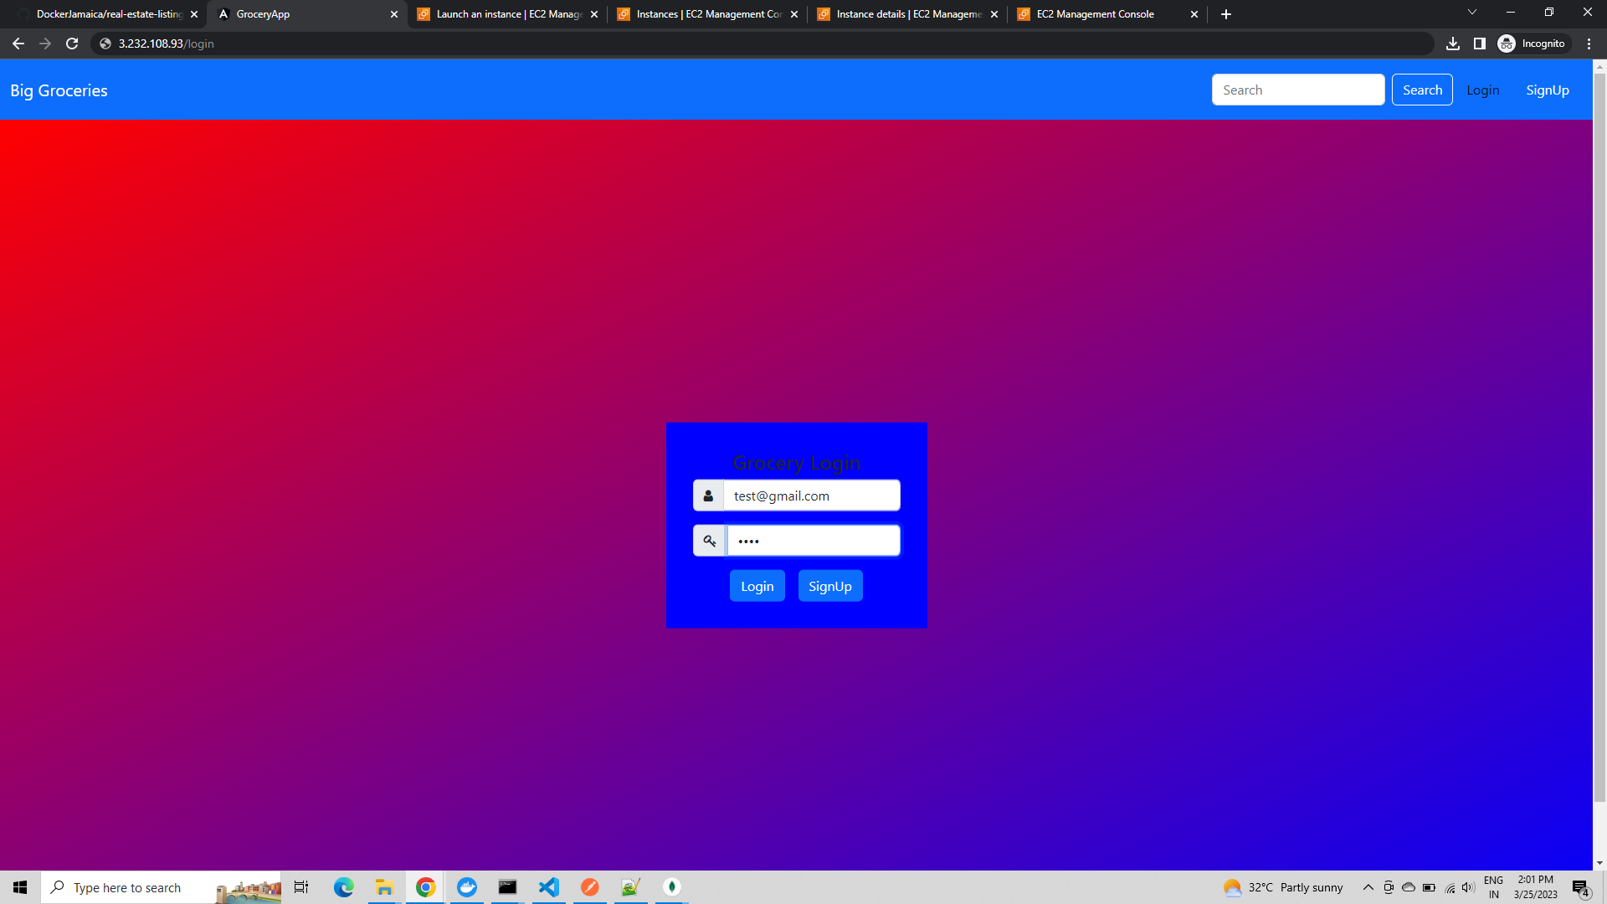

**User is logged into the home page**

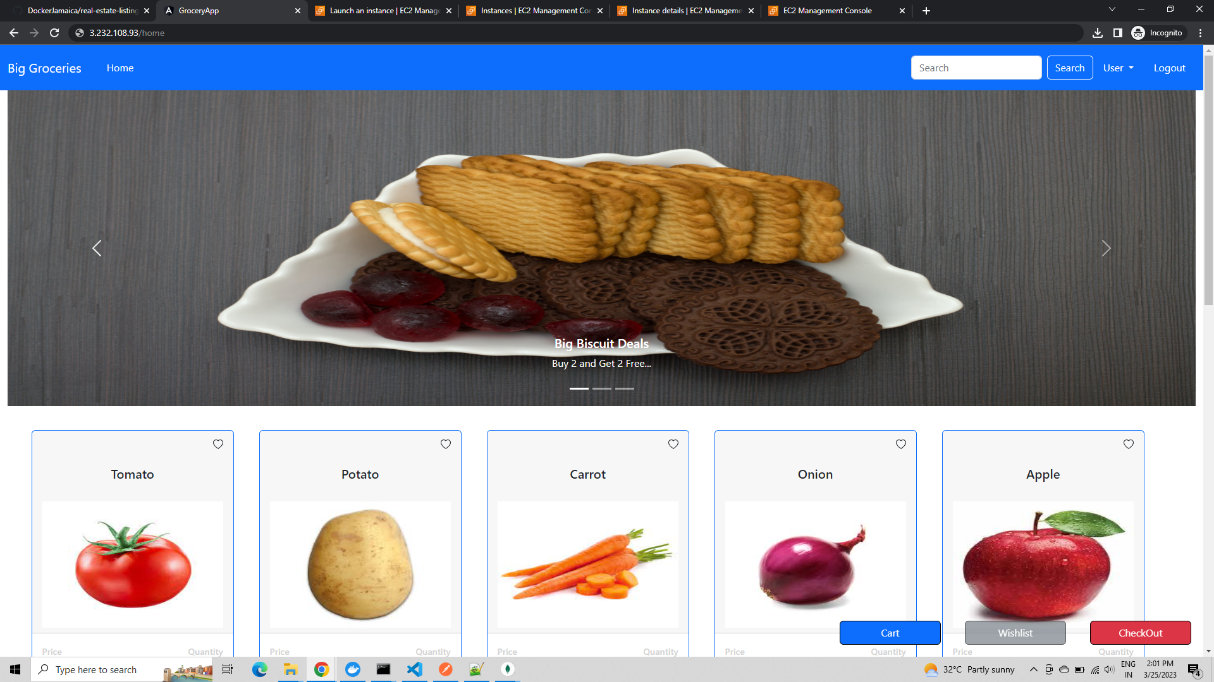

**Being a customer, can select the products present in the website and then order**

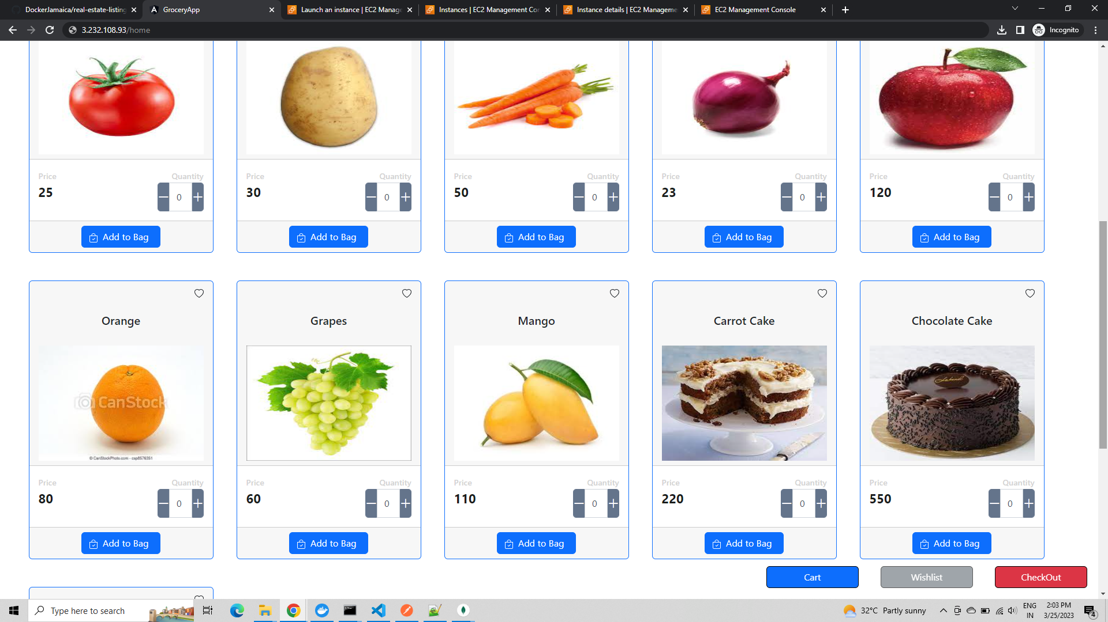

**User selects required products and presses the add to bag button for each item**

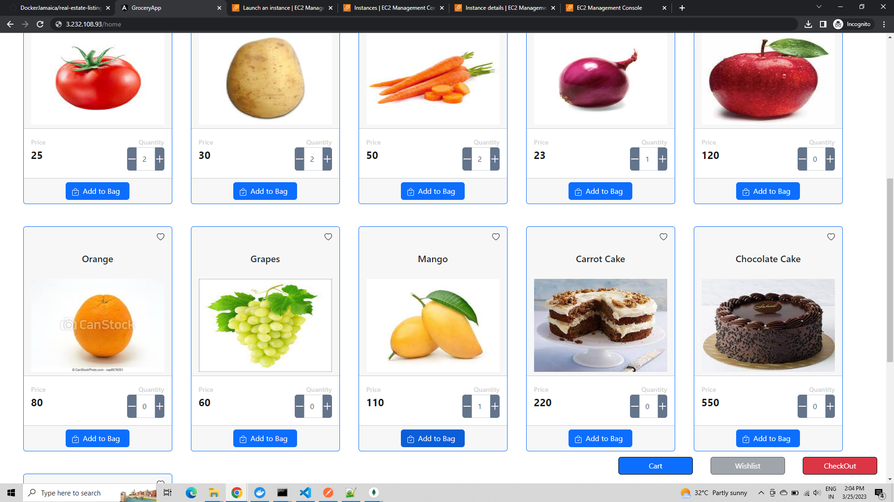

**On pressing the card button, the products selected are displayed.**

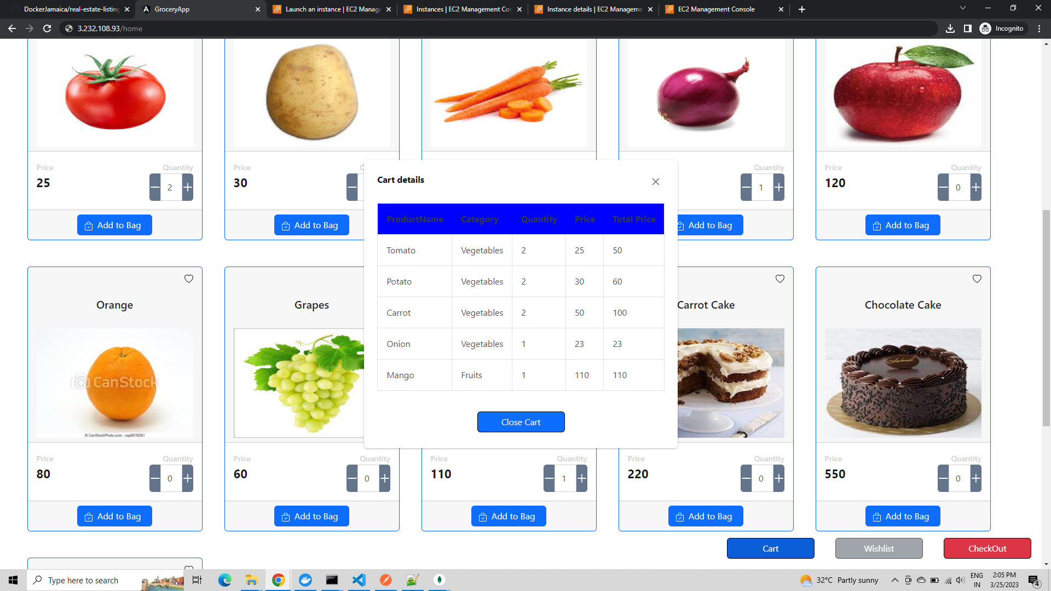

**Now the user can proceed to check out**

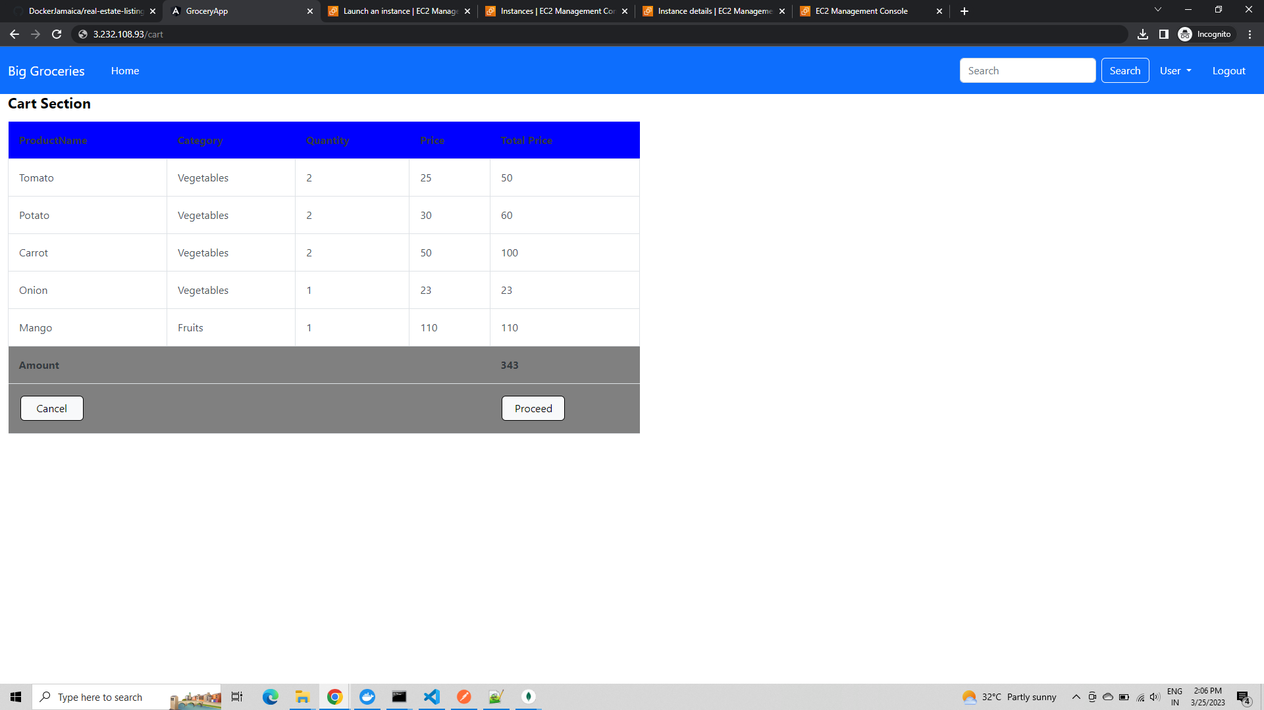

**On pressing the proceed button, the user is asked for confirmation.**

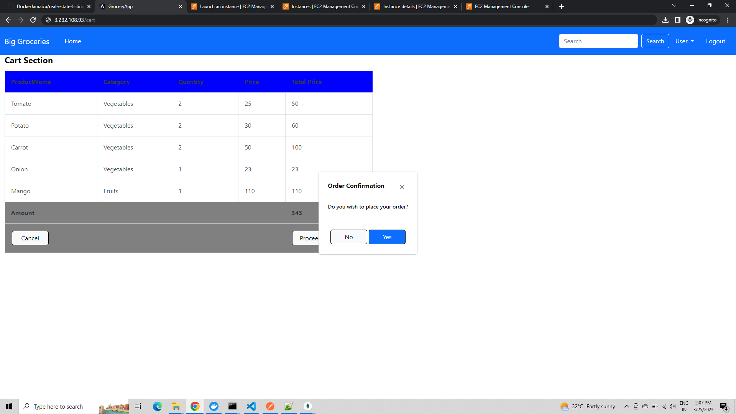

**On pressing Yes button, the order is generated and confirmation message is displayed.**

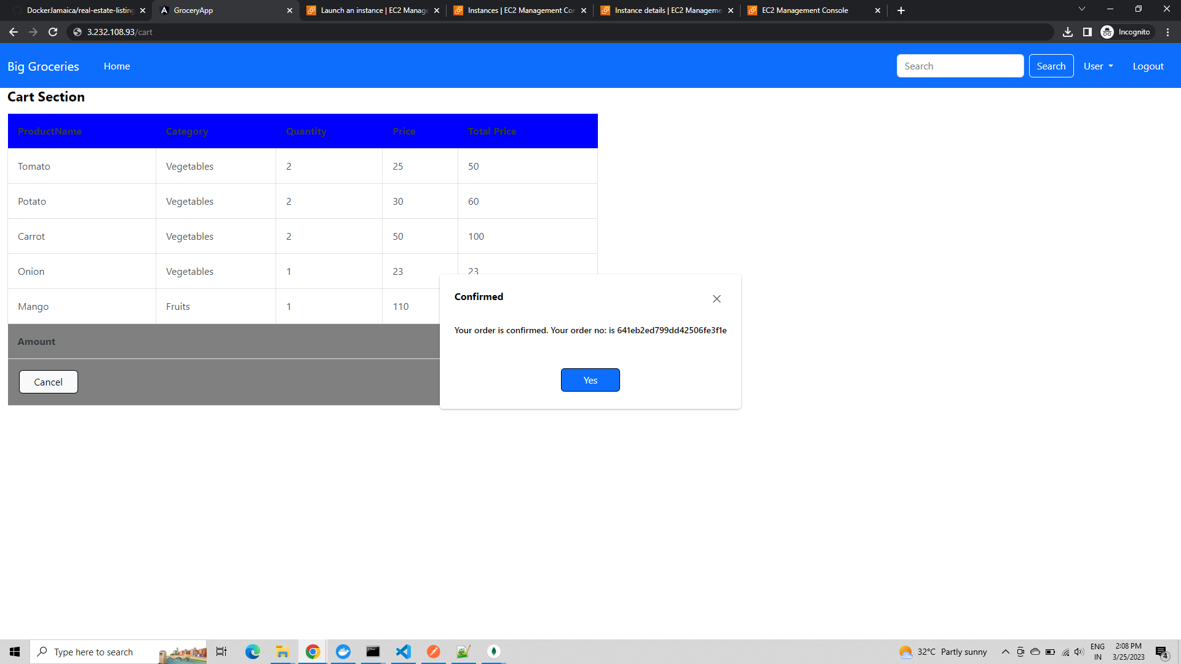

**On pressing Yes button, the user is redirected to home page.**

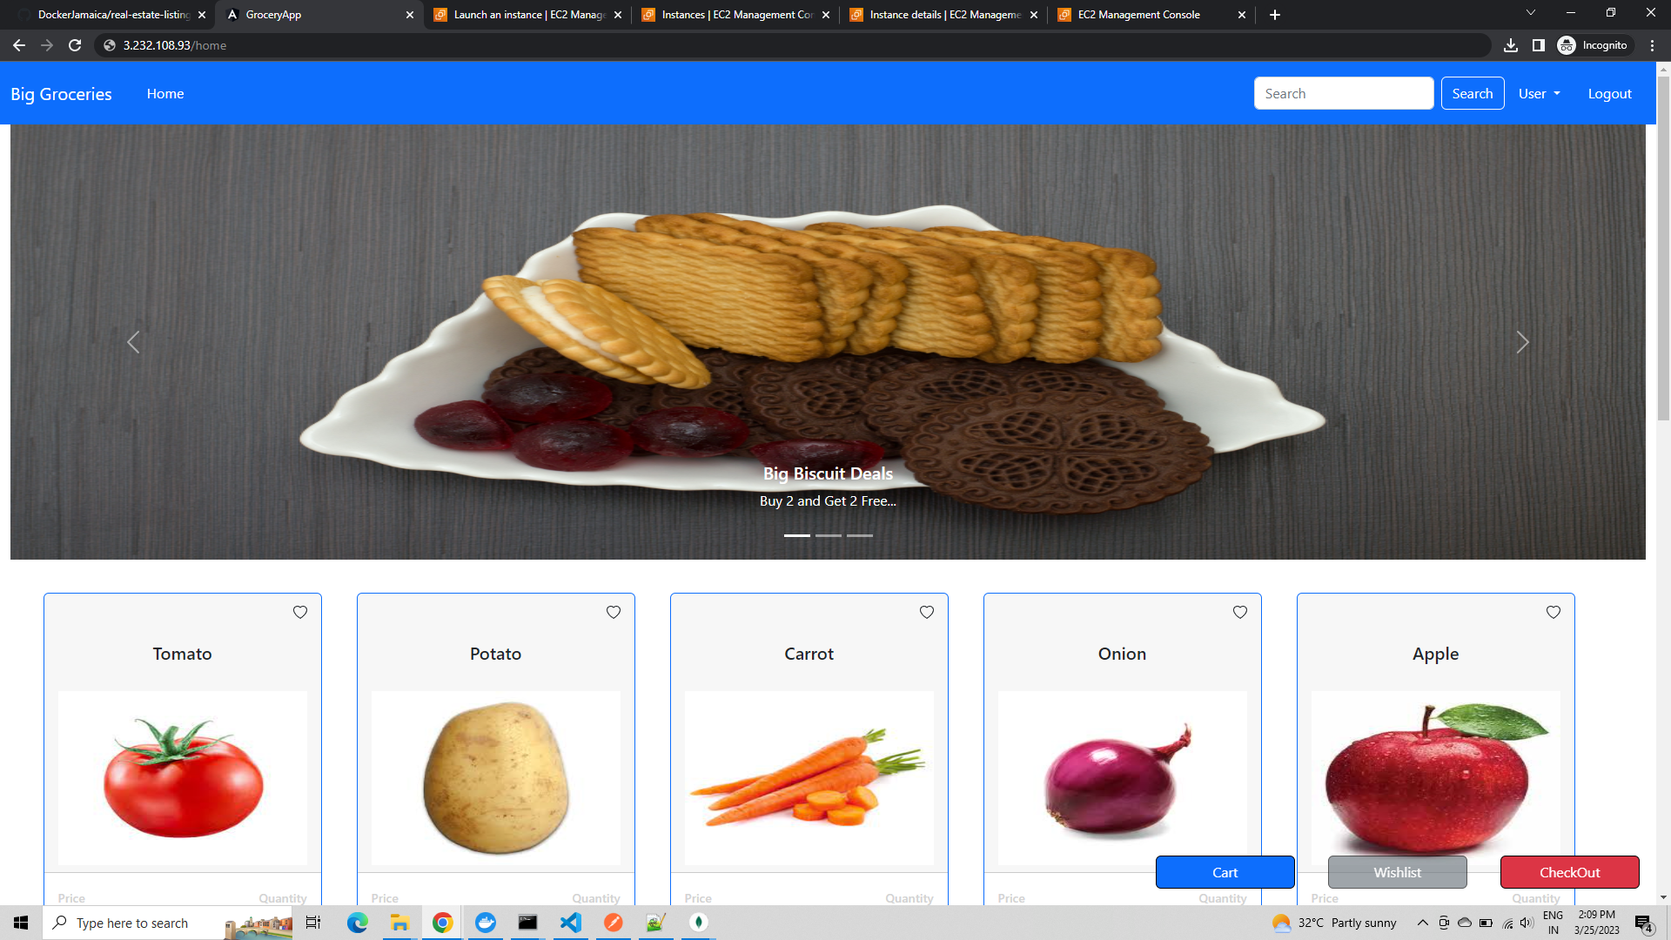

**The user can view the his orders as well.**

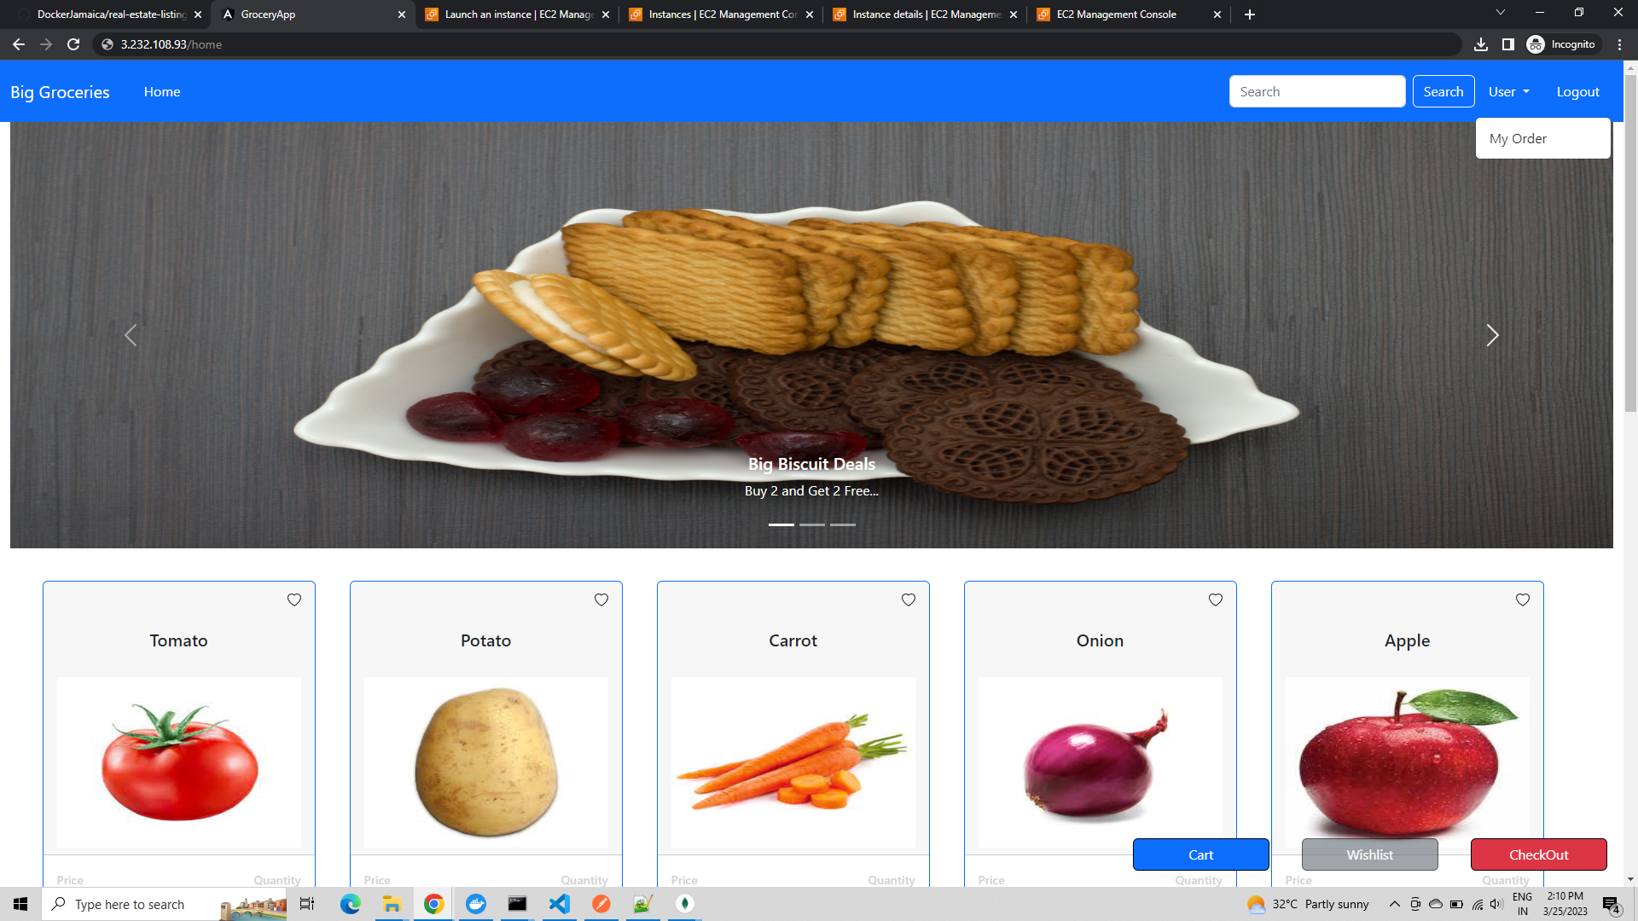

**On selecting the My orders section, the user is displayed the order details.**

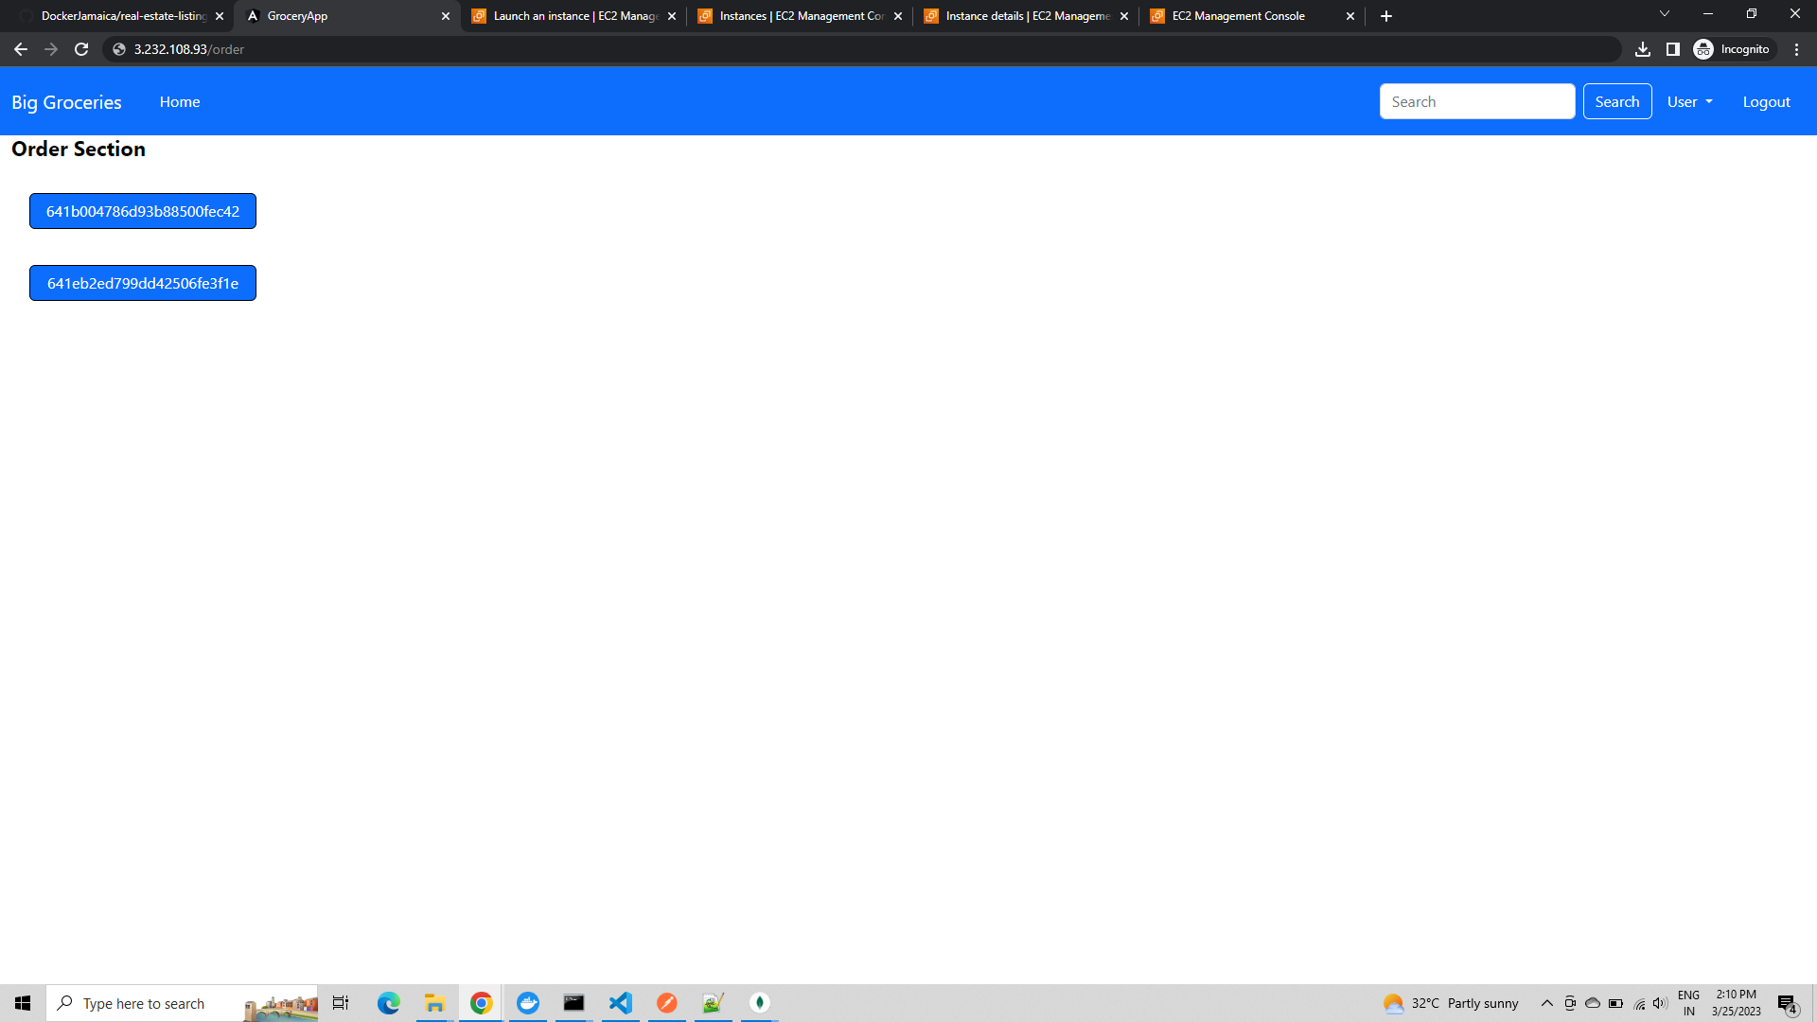

**On selecting the order Id, the user is displayed his order details.**

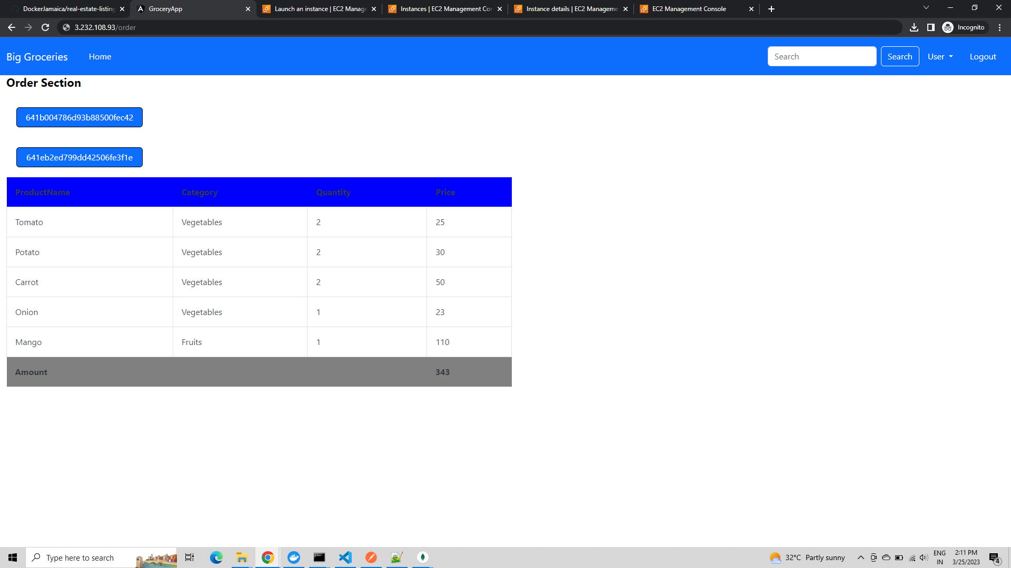

**Also the user has option to wishlist the items and see the wishlisted items for the session.**

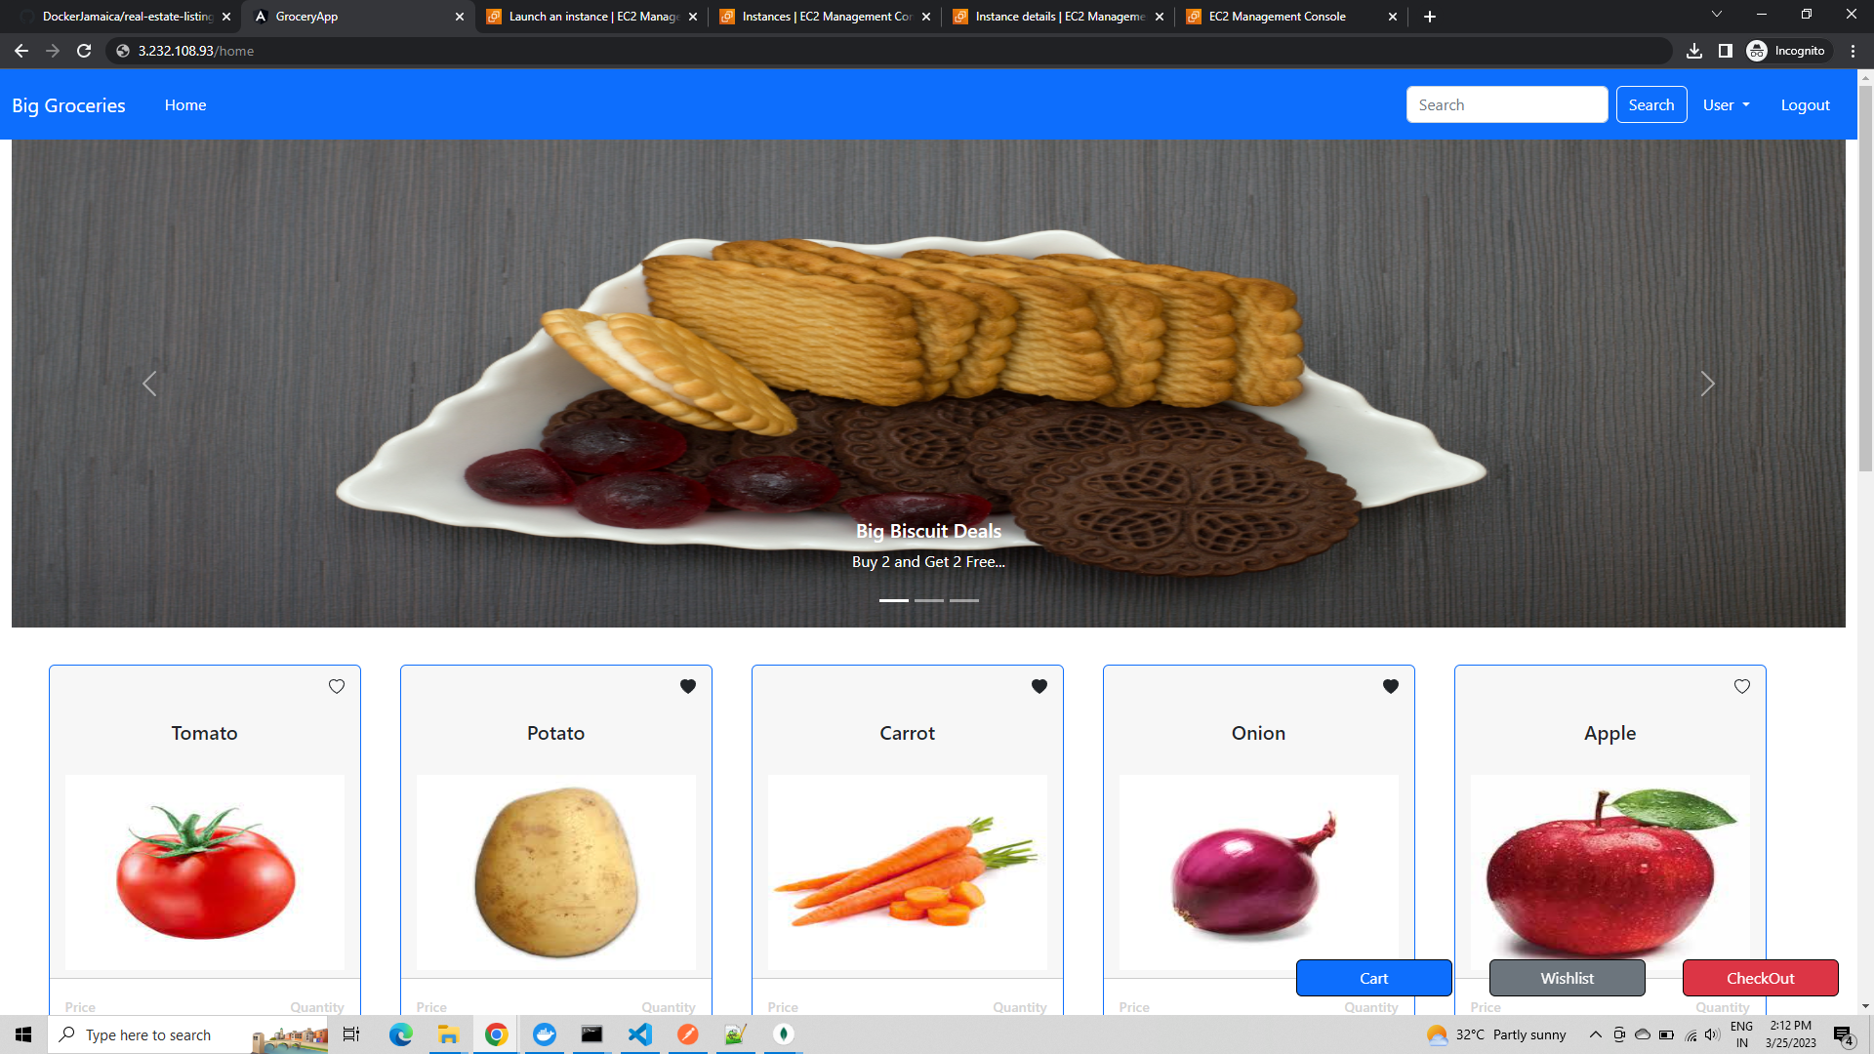

**On pressing the wishlist button**

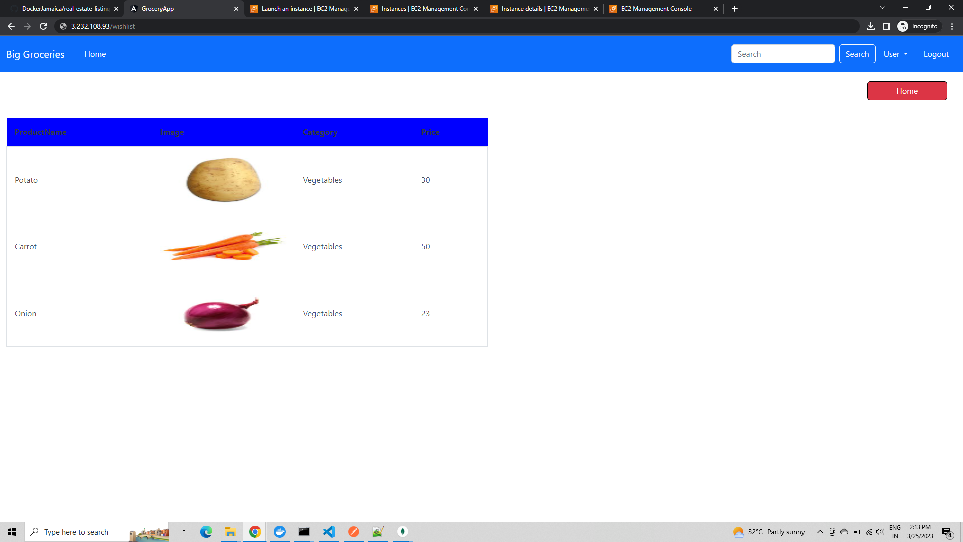

**Now, we can logout as customer and login as admin.**

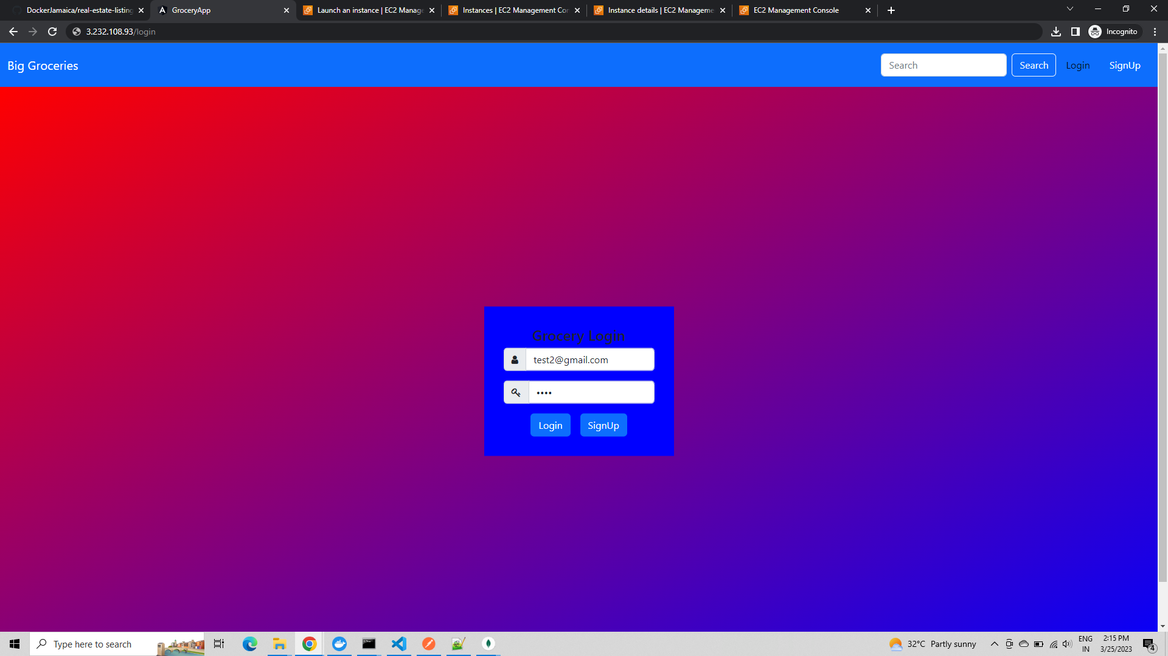

**There are few extra sections for admin user**

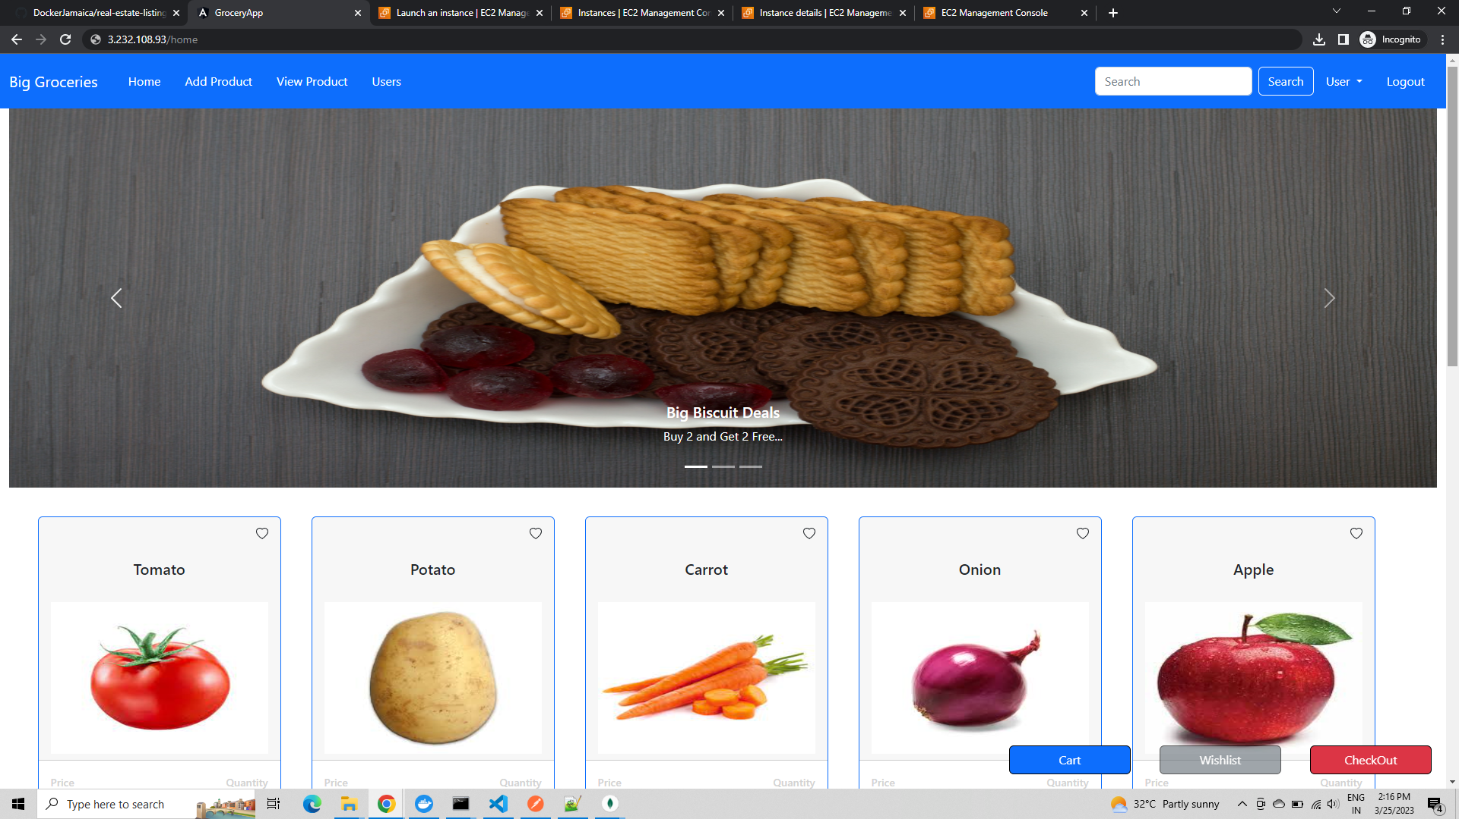

**Add Product section**

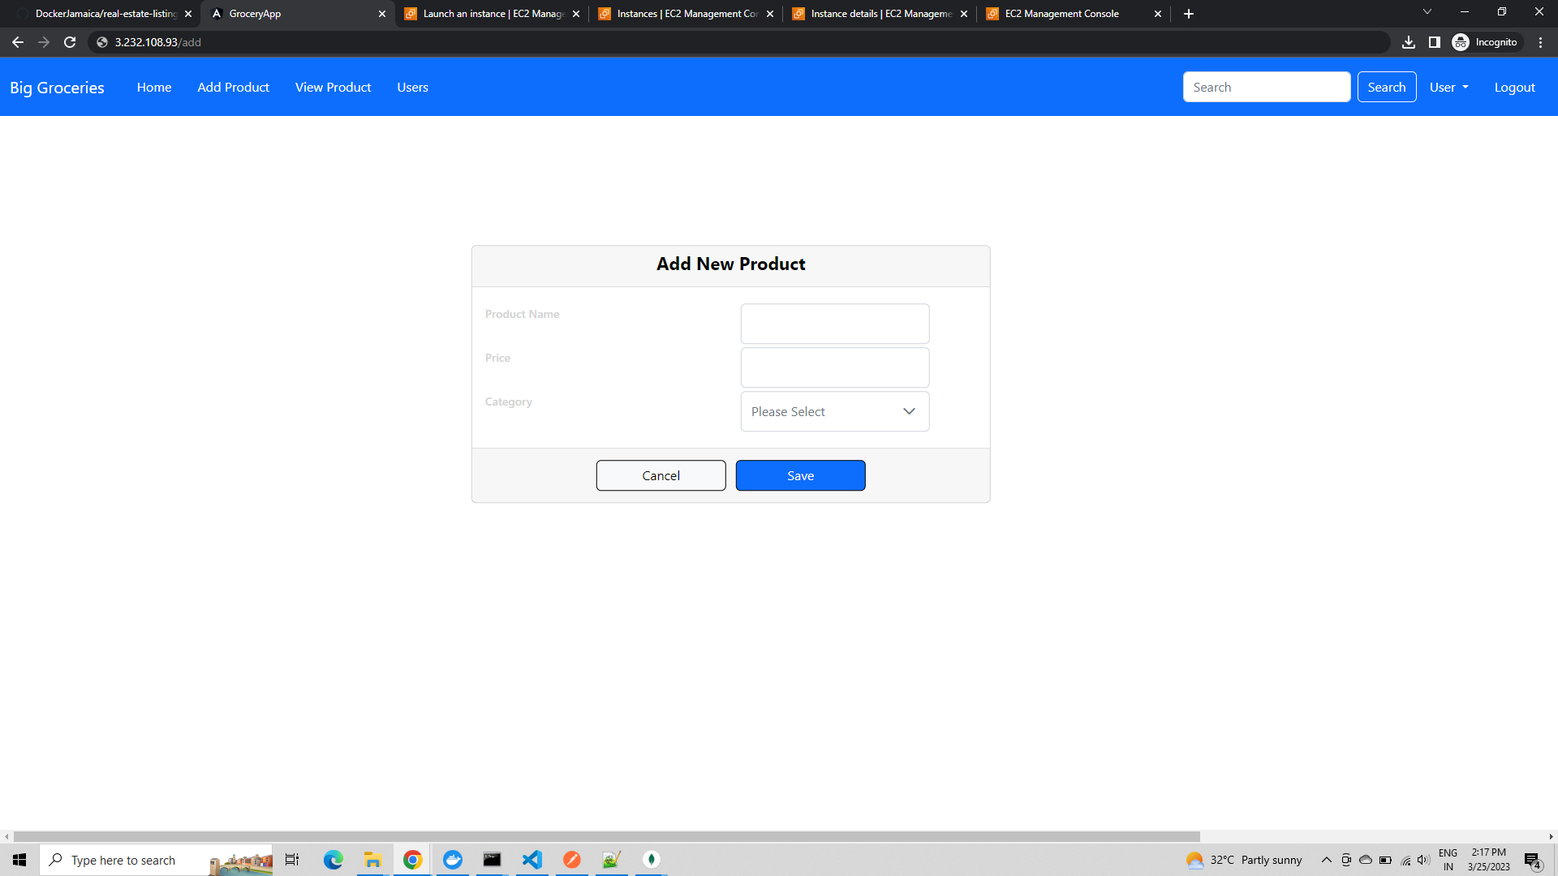

**View Product section with option to add/edit/delete products**

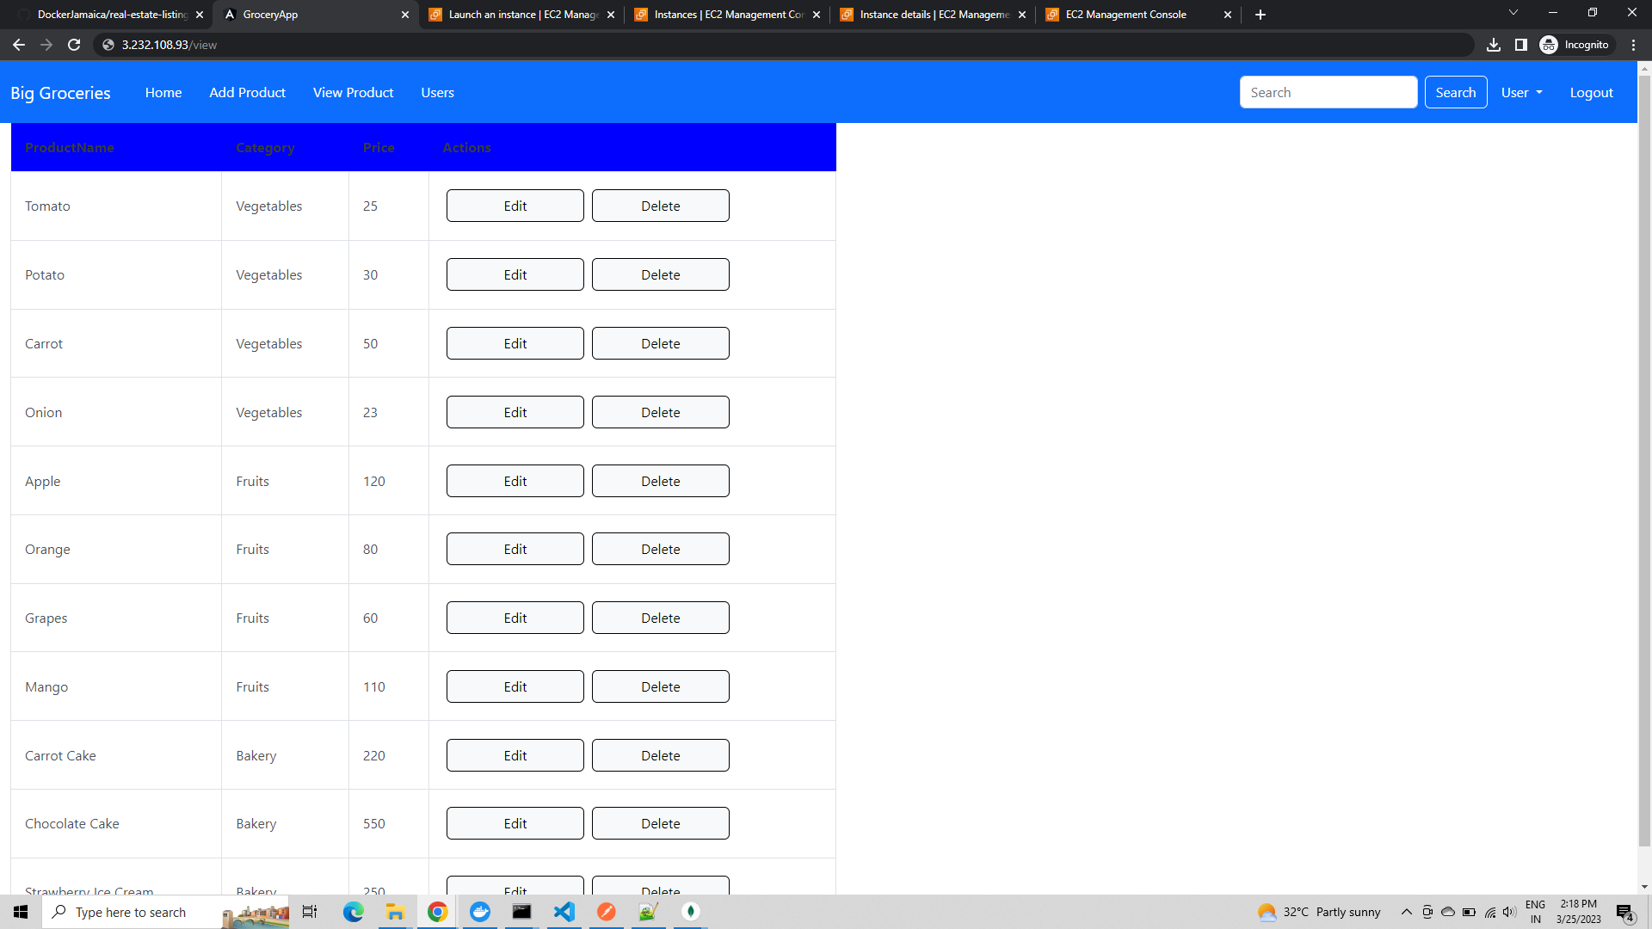

**On editing product and making changes, will get reflected in the home grocery page as well.**

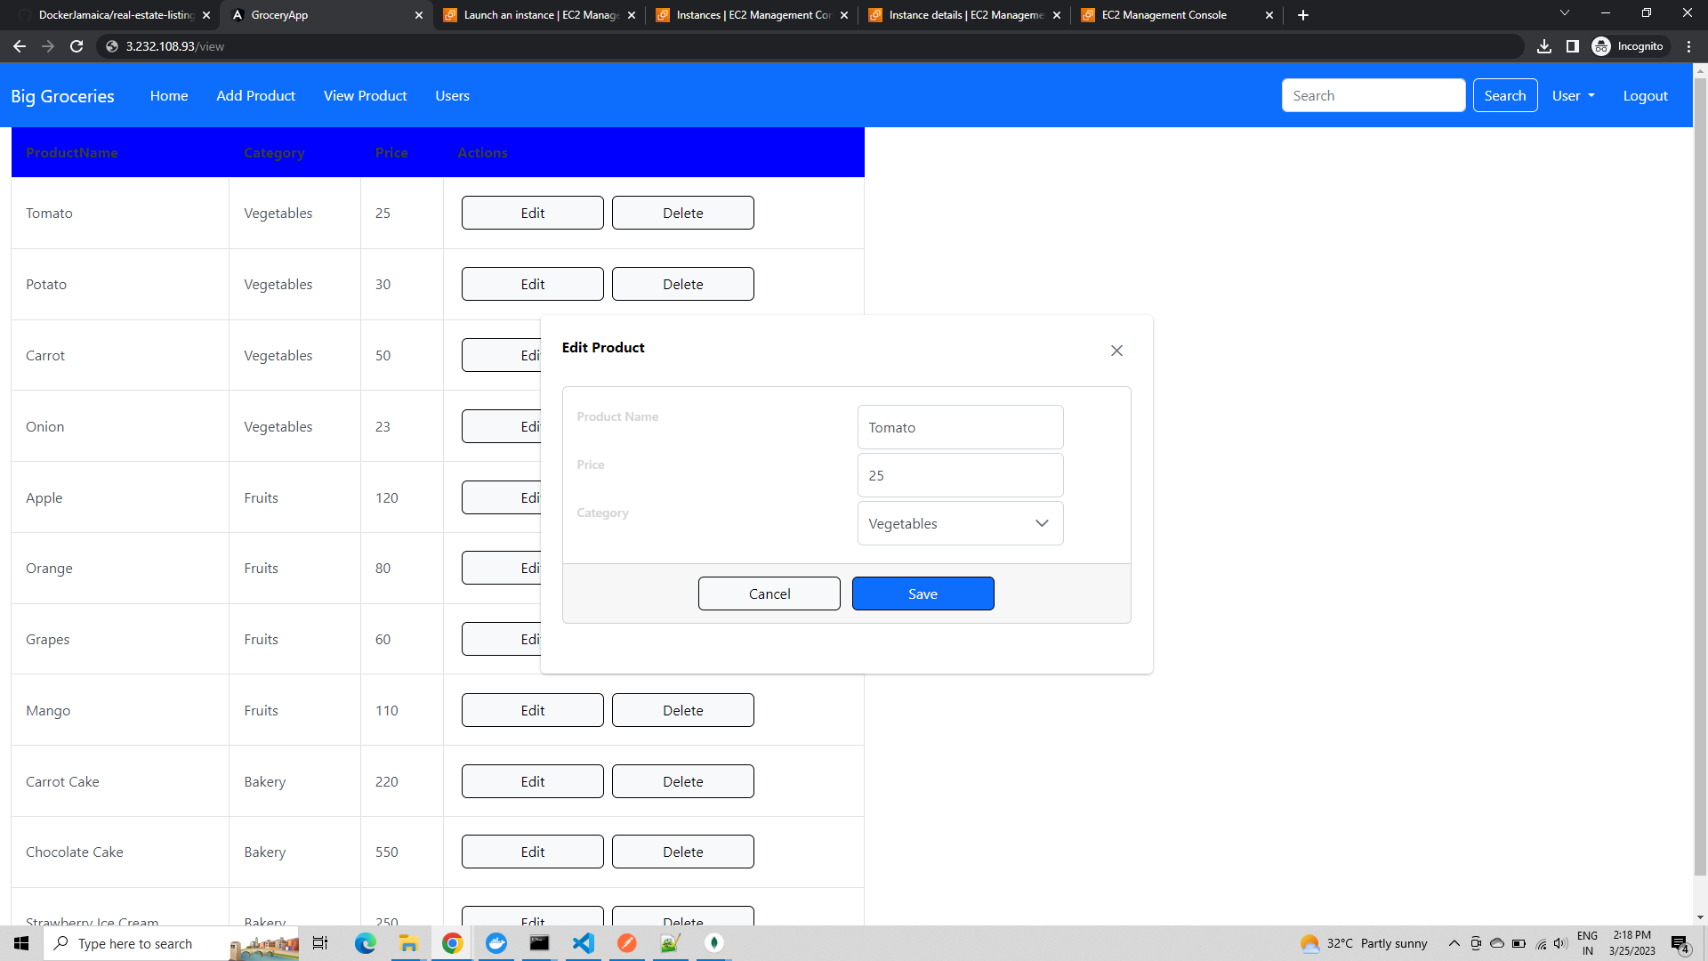

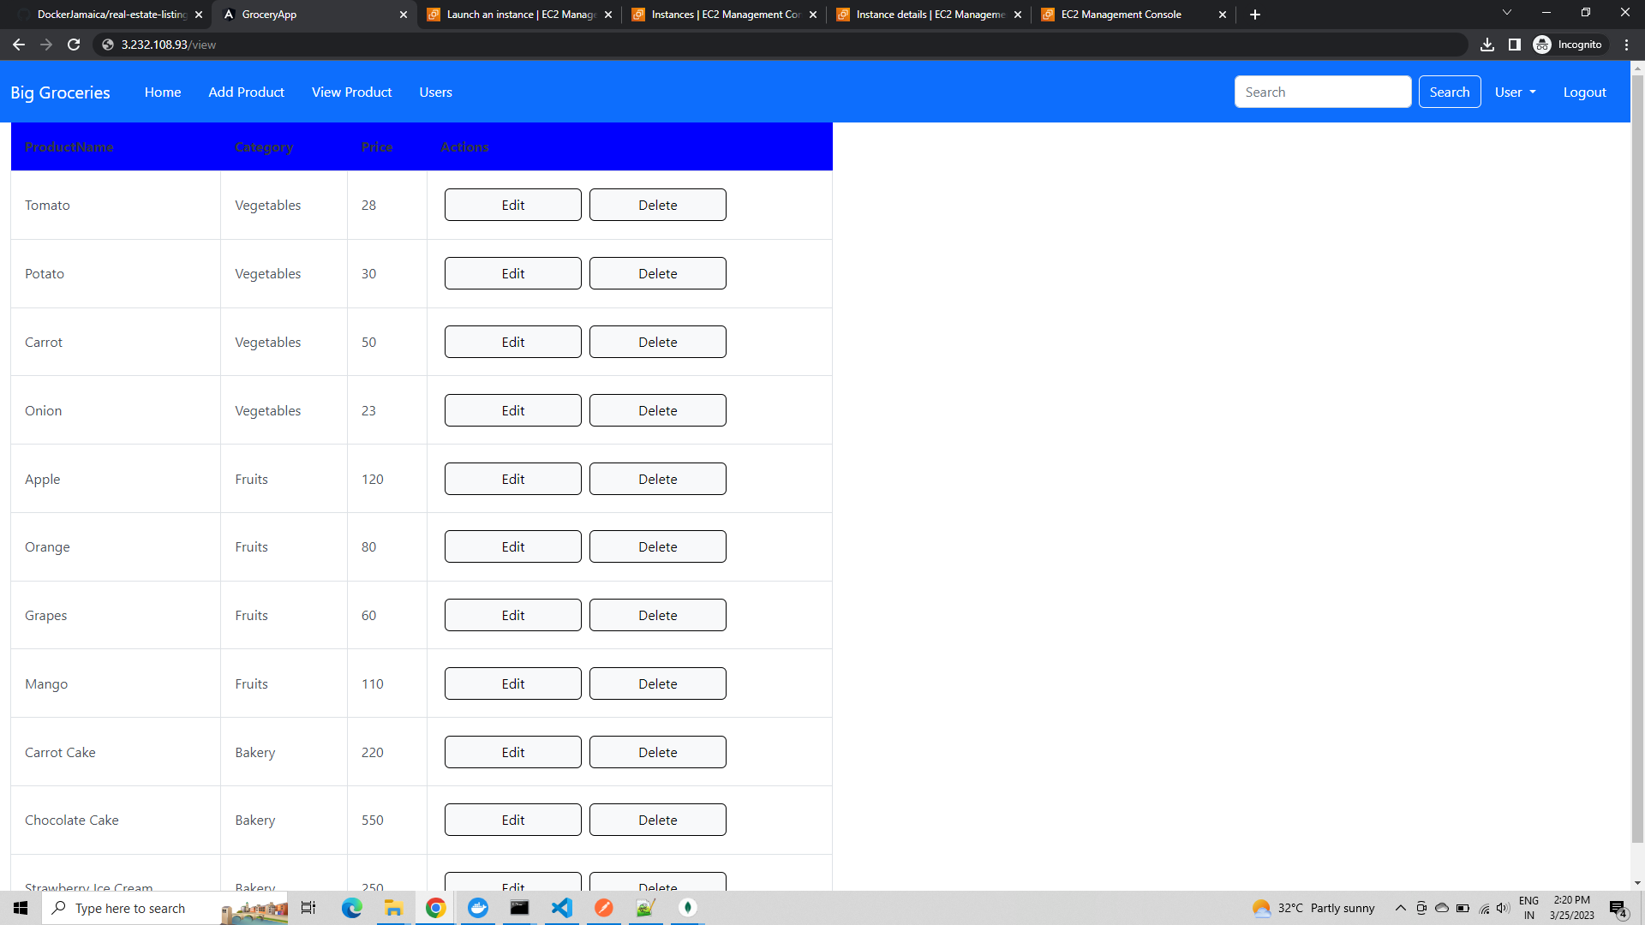

**On deleting the carrot cake product**

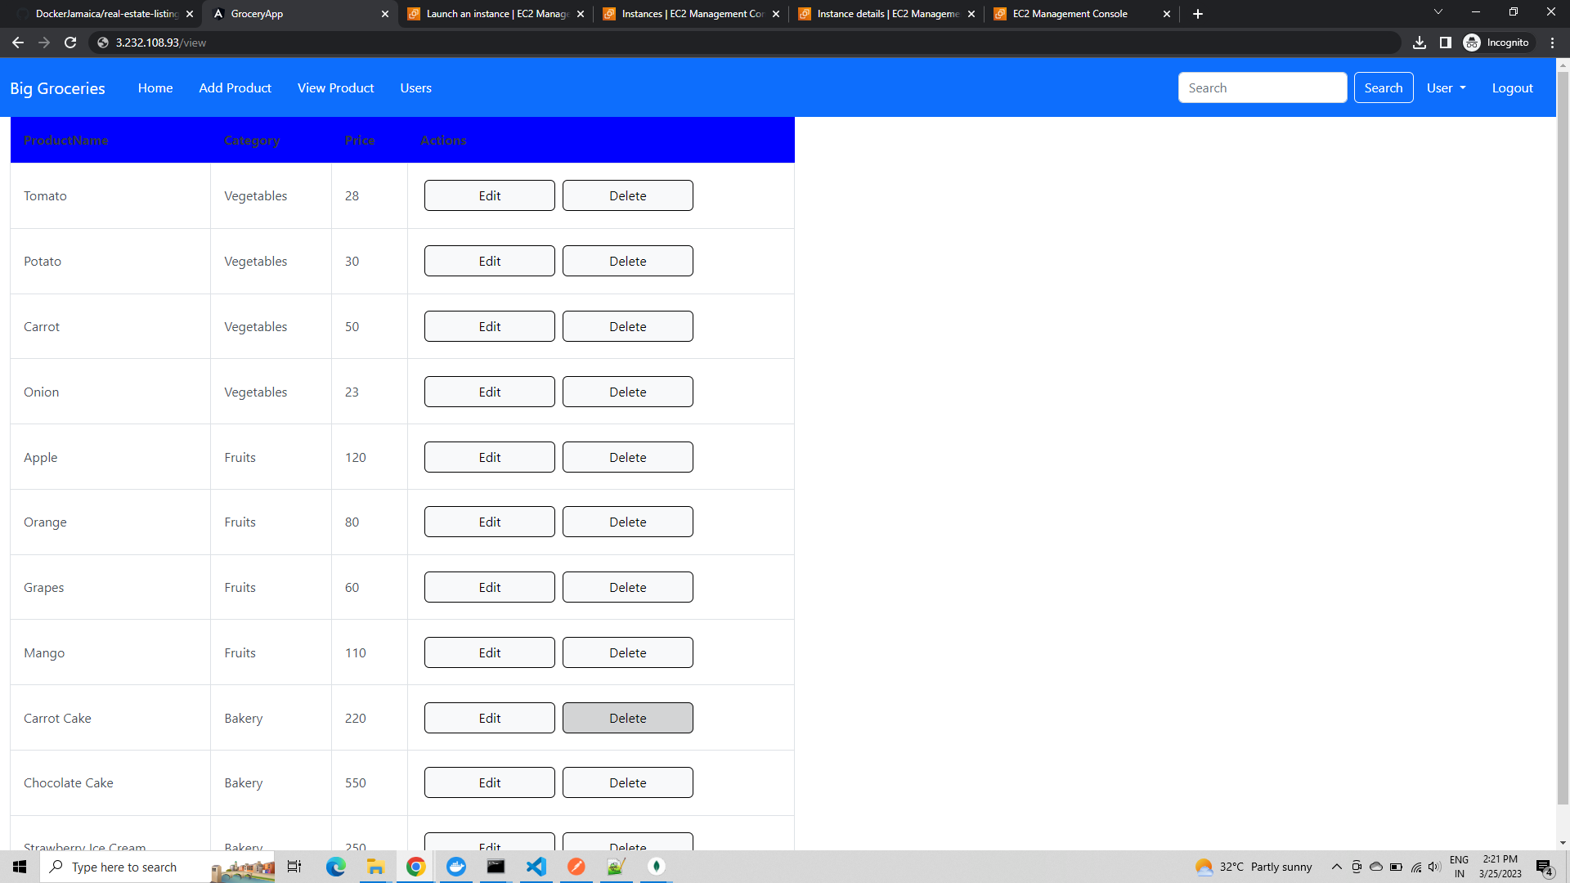

**The Product is deleted**

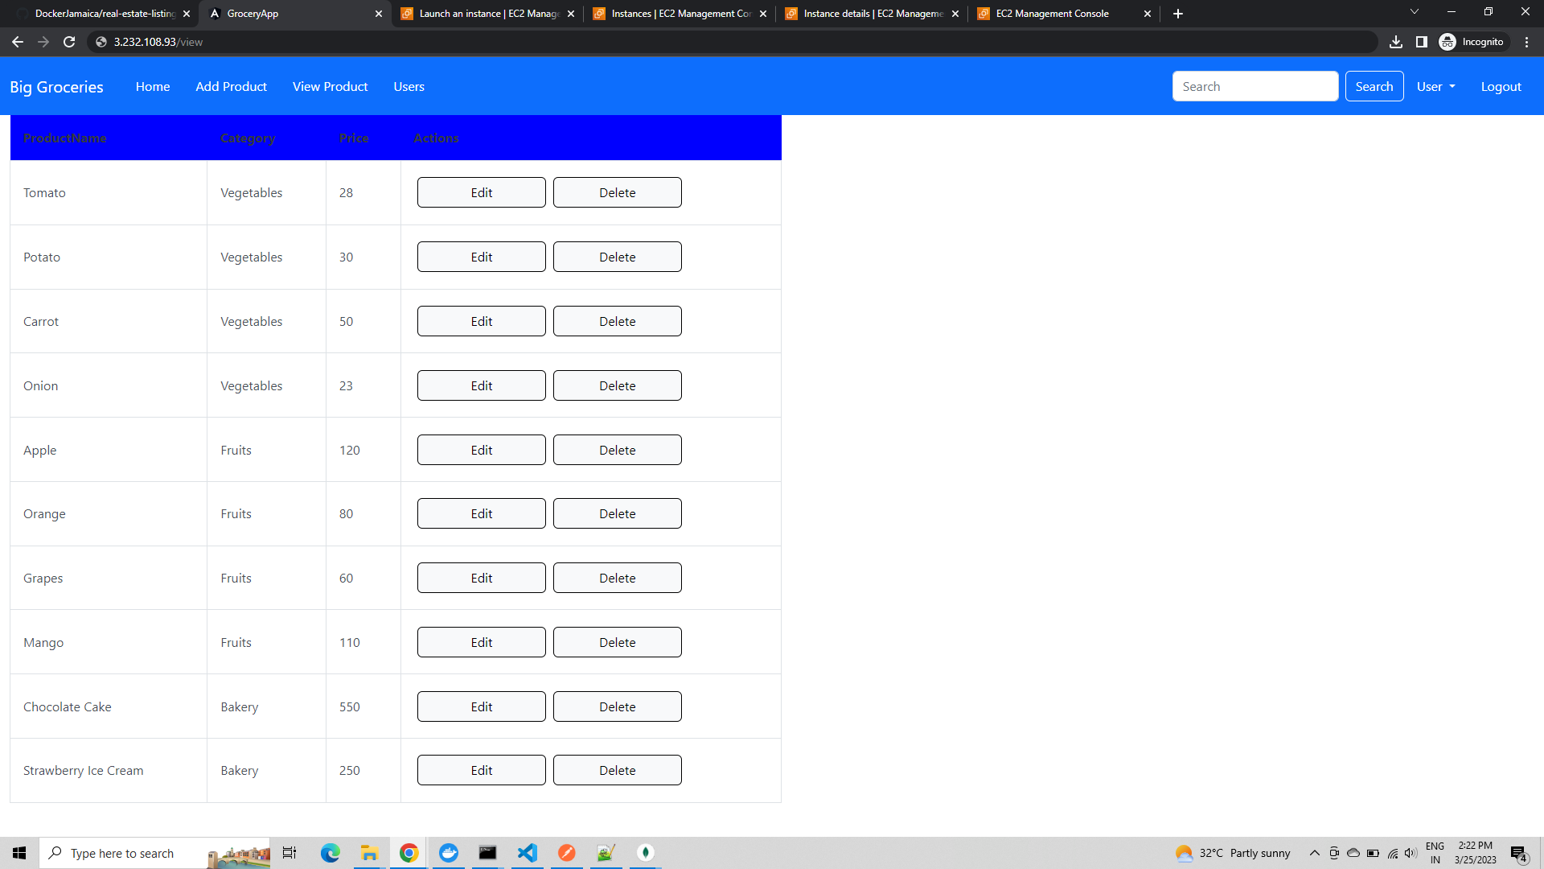

**On Verifying the home grocery screen, the product details have got updated and carrot cake has become removed.**

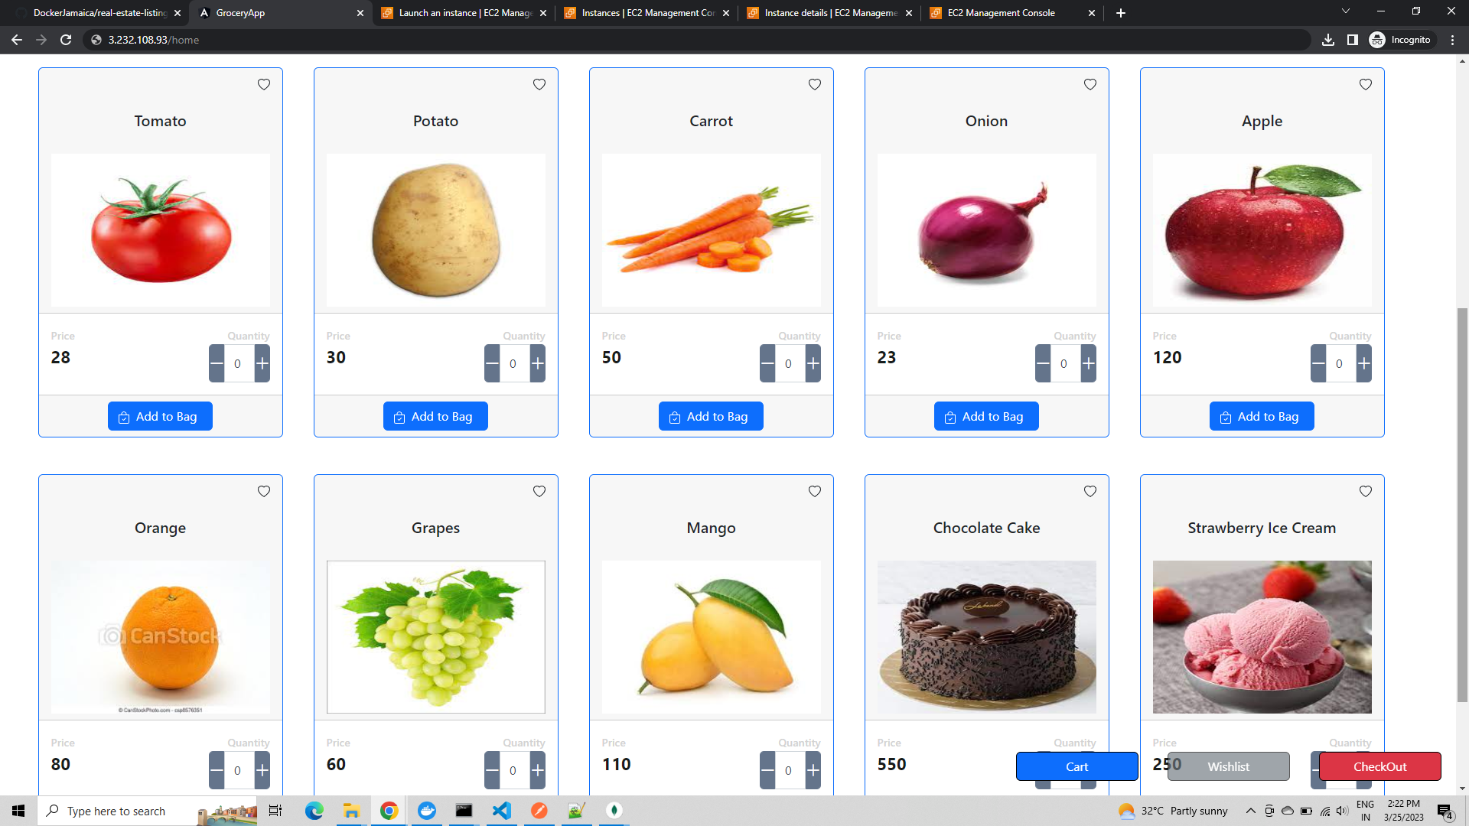

**Now, we go to the user screen**

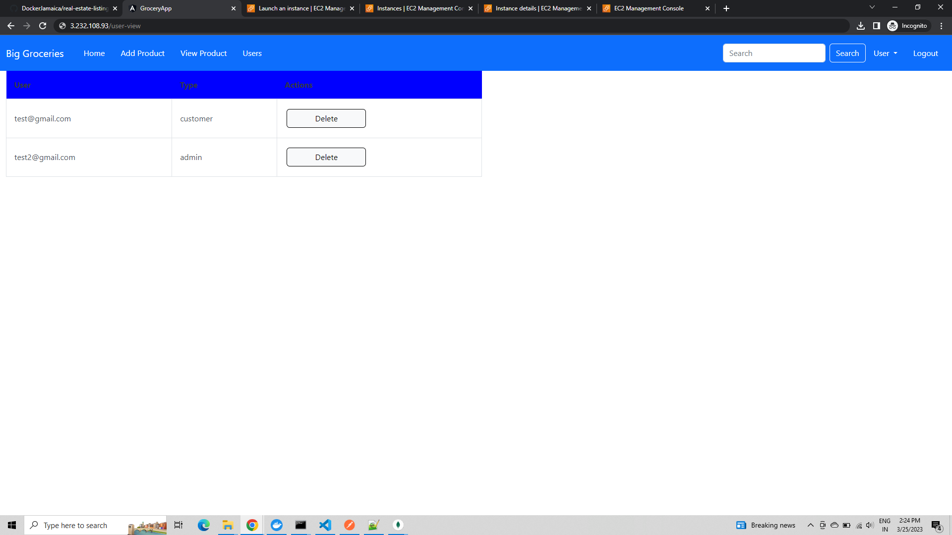

**Finally, we have the signup option to register as new user.**

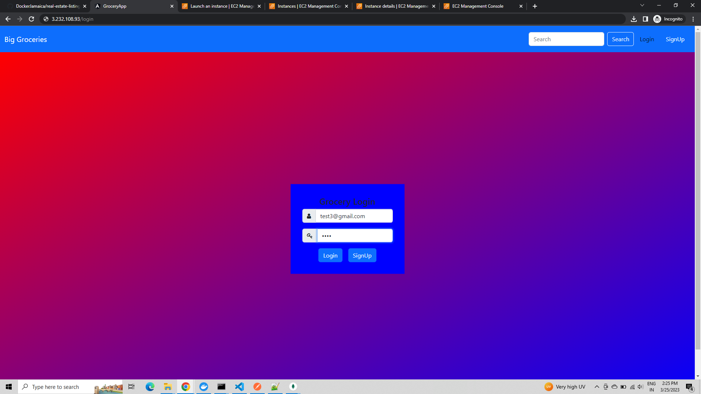

**User created on clicking sign up**



**Now, we can login**

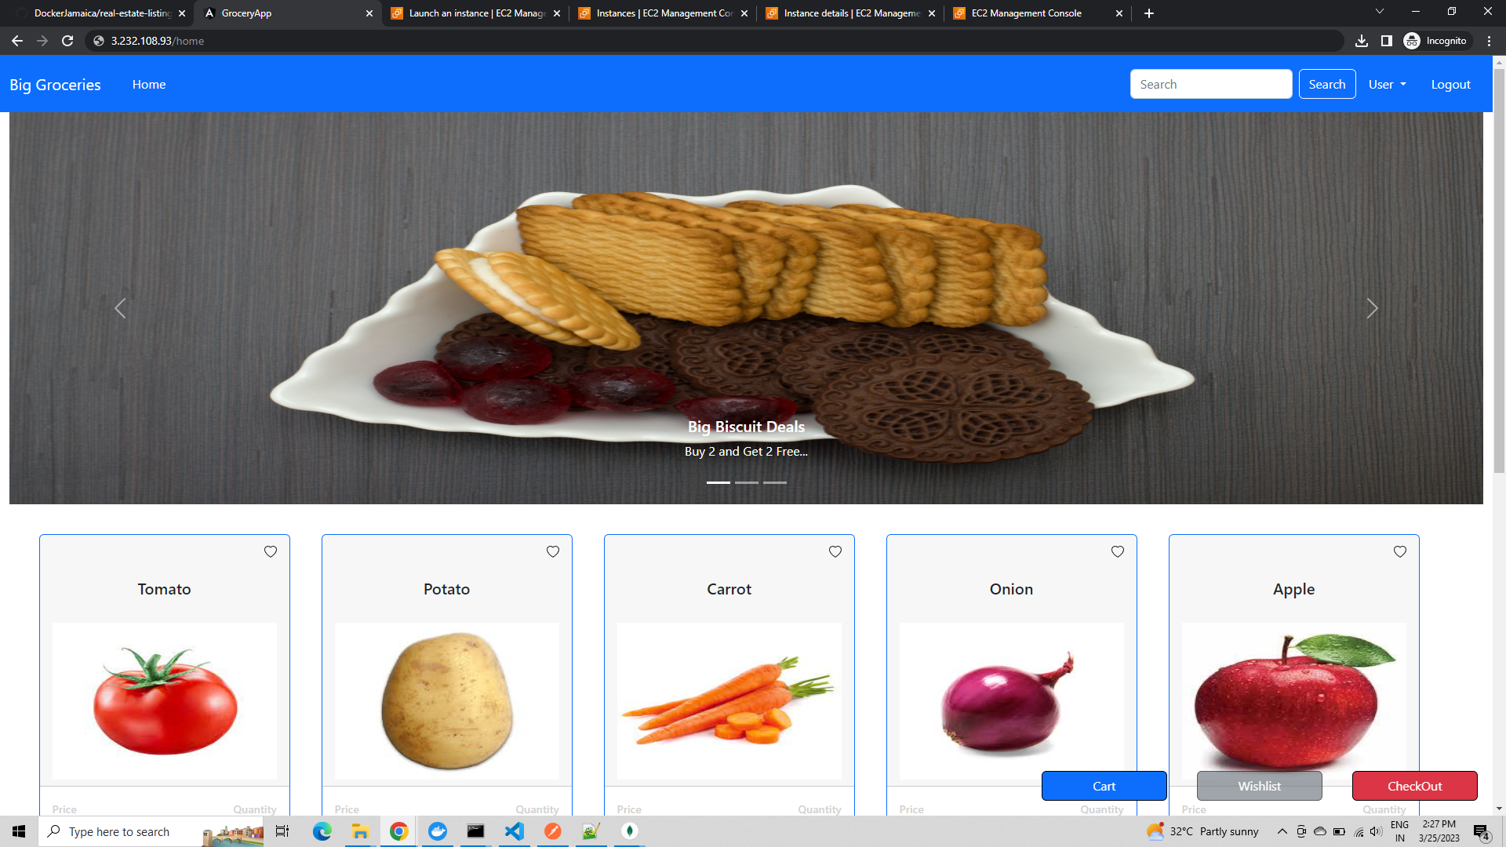

**All users signed up are customers. Now we can login as admin and delete the newly created user.**

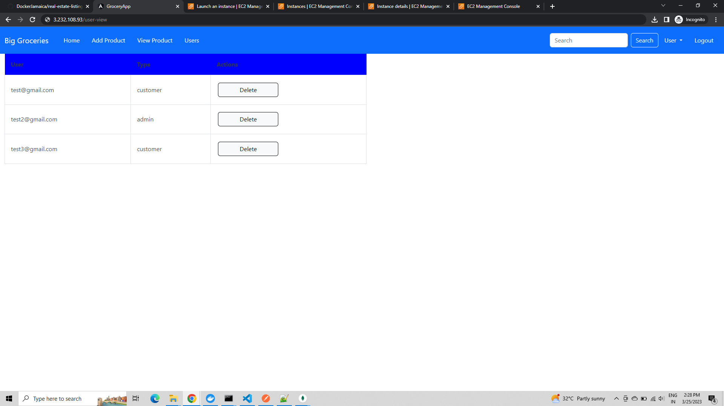

**Select the test3 user and press delete**

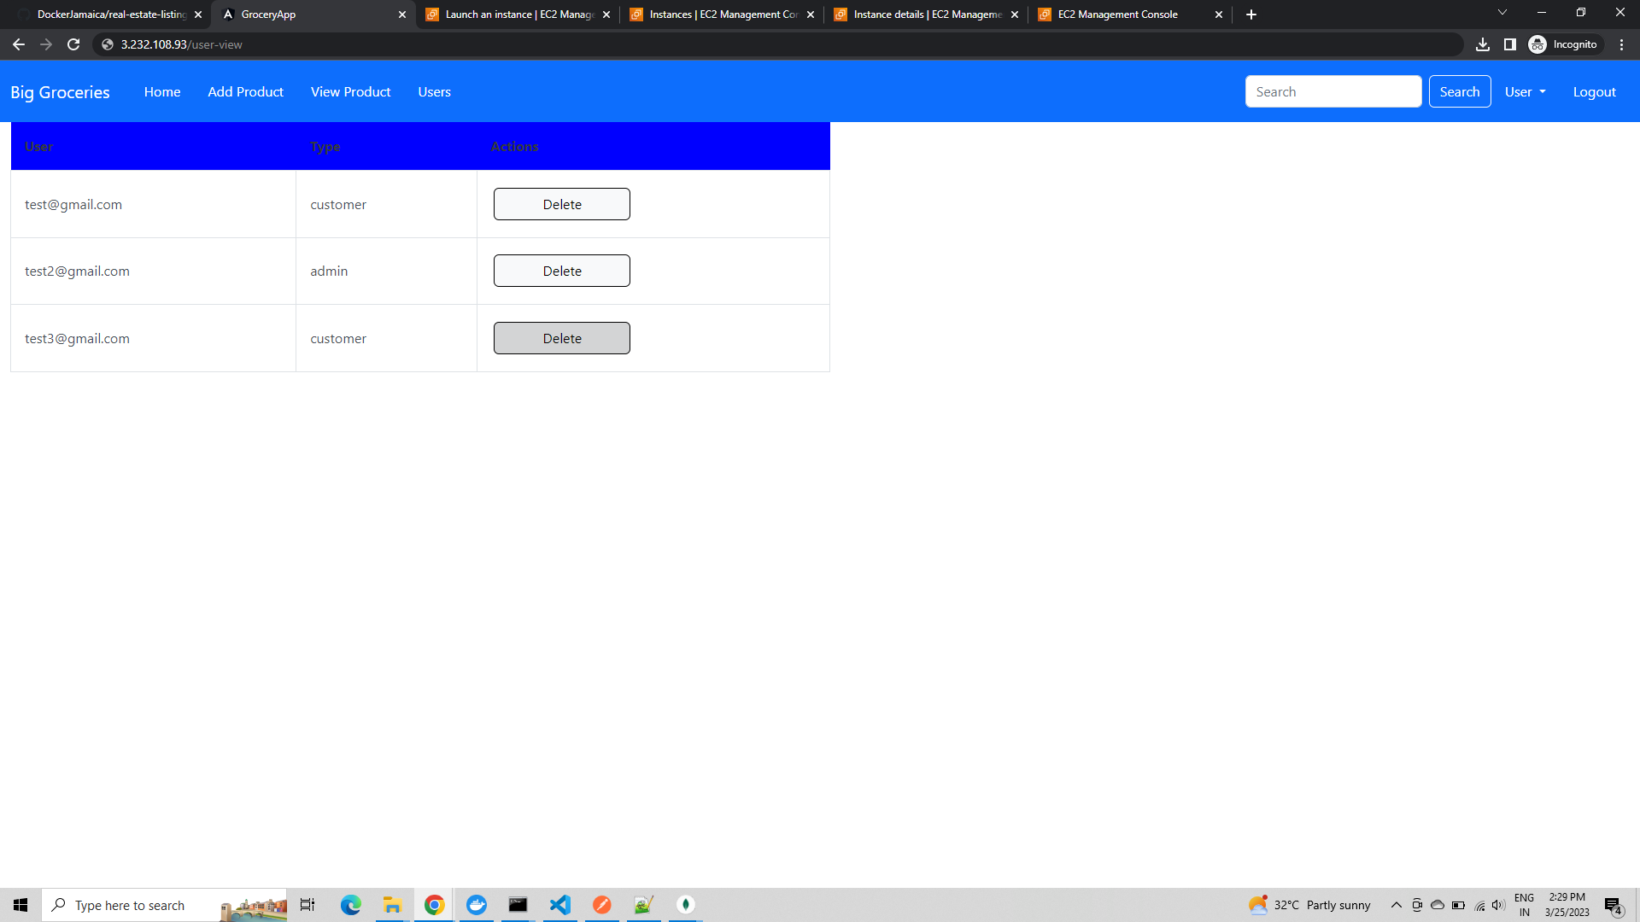

**The user has been deleted now**

